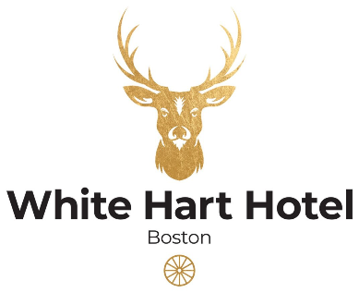

New Year’s Eve Pre-Order Form
Lead Guest Name: ____________________ Date of Booking: 31ST December 2023
Number of Guest: _____________________ Time of Booking:______________________

 | STARTER |  |  | MAIN |  |  | DESSERT
GUEST NAME | Classic French onion soup | Smoked mackerel tart | Chicken liver parfait, | Fillet & featherblade of beef | Monkfish tail, | Wild mushroom & truffle tagliatelle | Textures of raspberry, mousse, sorbet | Dark chocolate delice | Sticky toffee pudding, | Chef’s selection of cheese | ALLERGIES/DIETARY REQUIREMENTS

